**FOP**

Name : Muhammad Ali

CMS : 461603

Sec : ME-15 (B)

**Task#01**

#include <iostream>

using namespace std;

int main() {

for(int i=1; i<=150; i++){

if(i % 10 == 0) {

continue;

}

cout<<i<<" ";

}

return 0;

}

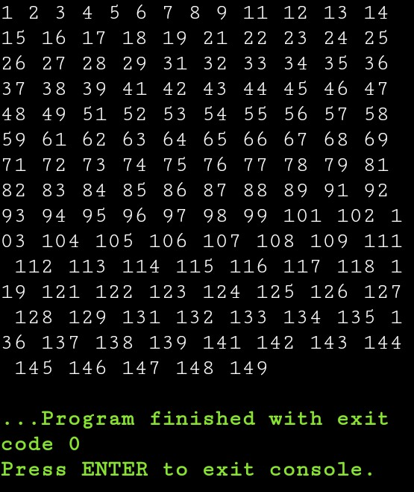

**Task#02**

include<iostream>

using namespace std;

int main()

{

int a, rem, sum=0;

cout<<"Enter the a : ";

cin>>a;

while(num>0)

{

rem = a%10;

sum = sum+rem;

a = a/10;

}

cout<<"\nSum of Digits = "<<sum;

cout<<endl;

return 0;

}

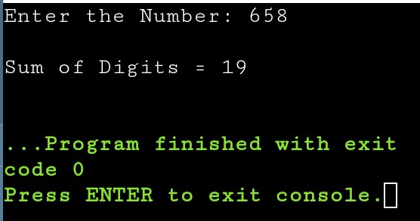

**Task#03**

#include <iostream>

using namespace std;

int main (){

int number;

bool prime = false;

cout<<"Enter the number : ";

cin>>number;

for(int i=2;i<number;i++)

{

if(number%i == 0)

{

prime = false;

break;

}

else {

prime= true;

continue;

}

}

if (prime==true)

cout<<"This number is a prime number";

else if(prime==false)

cout<<"This number is NOT a prime Number";

return 0;}

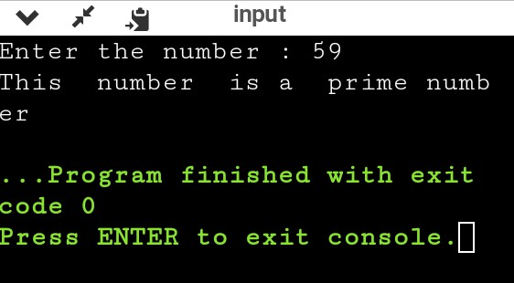

***END***